PowerSchool Registration Directions

Directions for Entering Course Requests into PowerScheduler

This year parents and students will be entering their 2023-24 course requests into the “Electronic Course Card” Google Form FIRST and then into PowerSchool. Please read all information on the “Registration Process for the 2023-24 Academic Year” before selecting courses.

**A Few Reminders:**

1. **It is important that your selections on PowerSchool match the “Electronic Course Card” google form selections. SCMS will use the Electronic Course Card as the final document for finalizing schedules.** If you made a mistake on the “Electronic Course Card” please do not resubmit, but email [whitneyr.matthews@cms.k12.nc.us](mailto:whitneyr.matthews@cms.k12.nc.us).
2. If you are **not zoned for SCMS** then you will not have access to PowerSchool Registration. If you are not zoned, then you will need to simply fill out the Electronic Course Card Google Form. We will enter your course requests into PowerSchool as soon you are transferred. If you have questions about how to transfer to SCMS, please contact our registrar, Kim Pace at [kimberlya.pace@cms.k12.nc.us](mailto:kimberlya.pace@cms.k12.nc.us)
3. If after following all instructions and videos located on our website “Registration Process for 2023-24 Academic Year” you have questions, please contact Whitney Matthews at [whitneyr.matthews@cms.k12.nc.us](mailto:whitneyr.matthews@cms.k12.nc.us)

**Directions:**

* Students know how to log into their NCEdCloud Account: my.ncedcloud.org (do not put www. in front of web address)

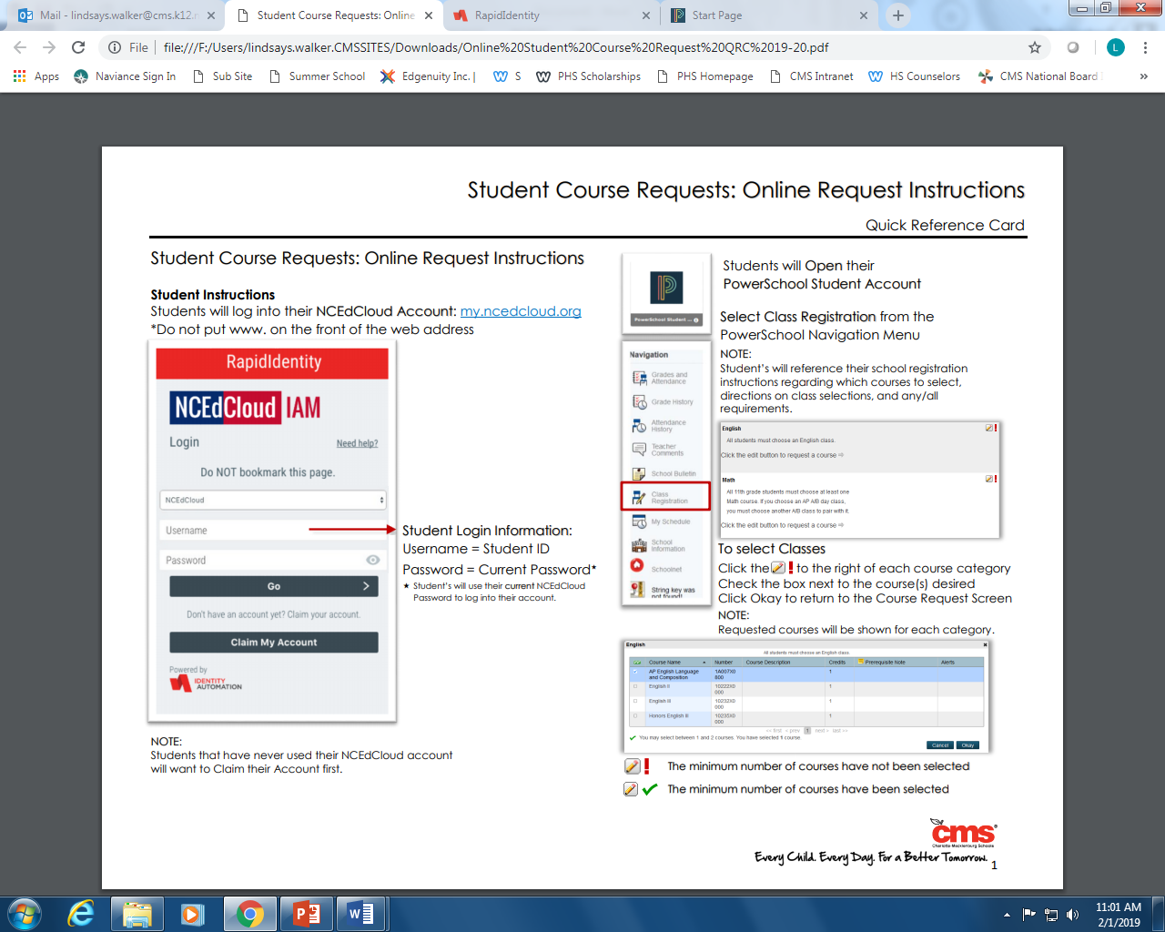

* Students will open their PowerSchool Student Account.
* Select “Class Registration” from the PowerSchool navigation menu

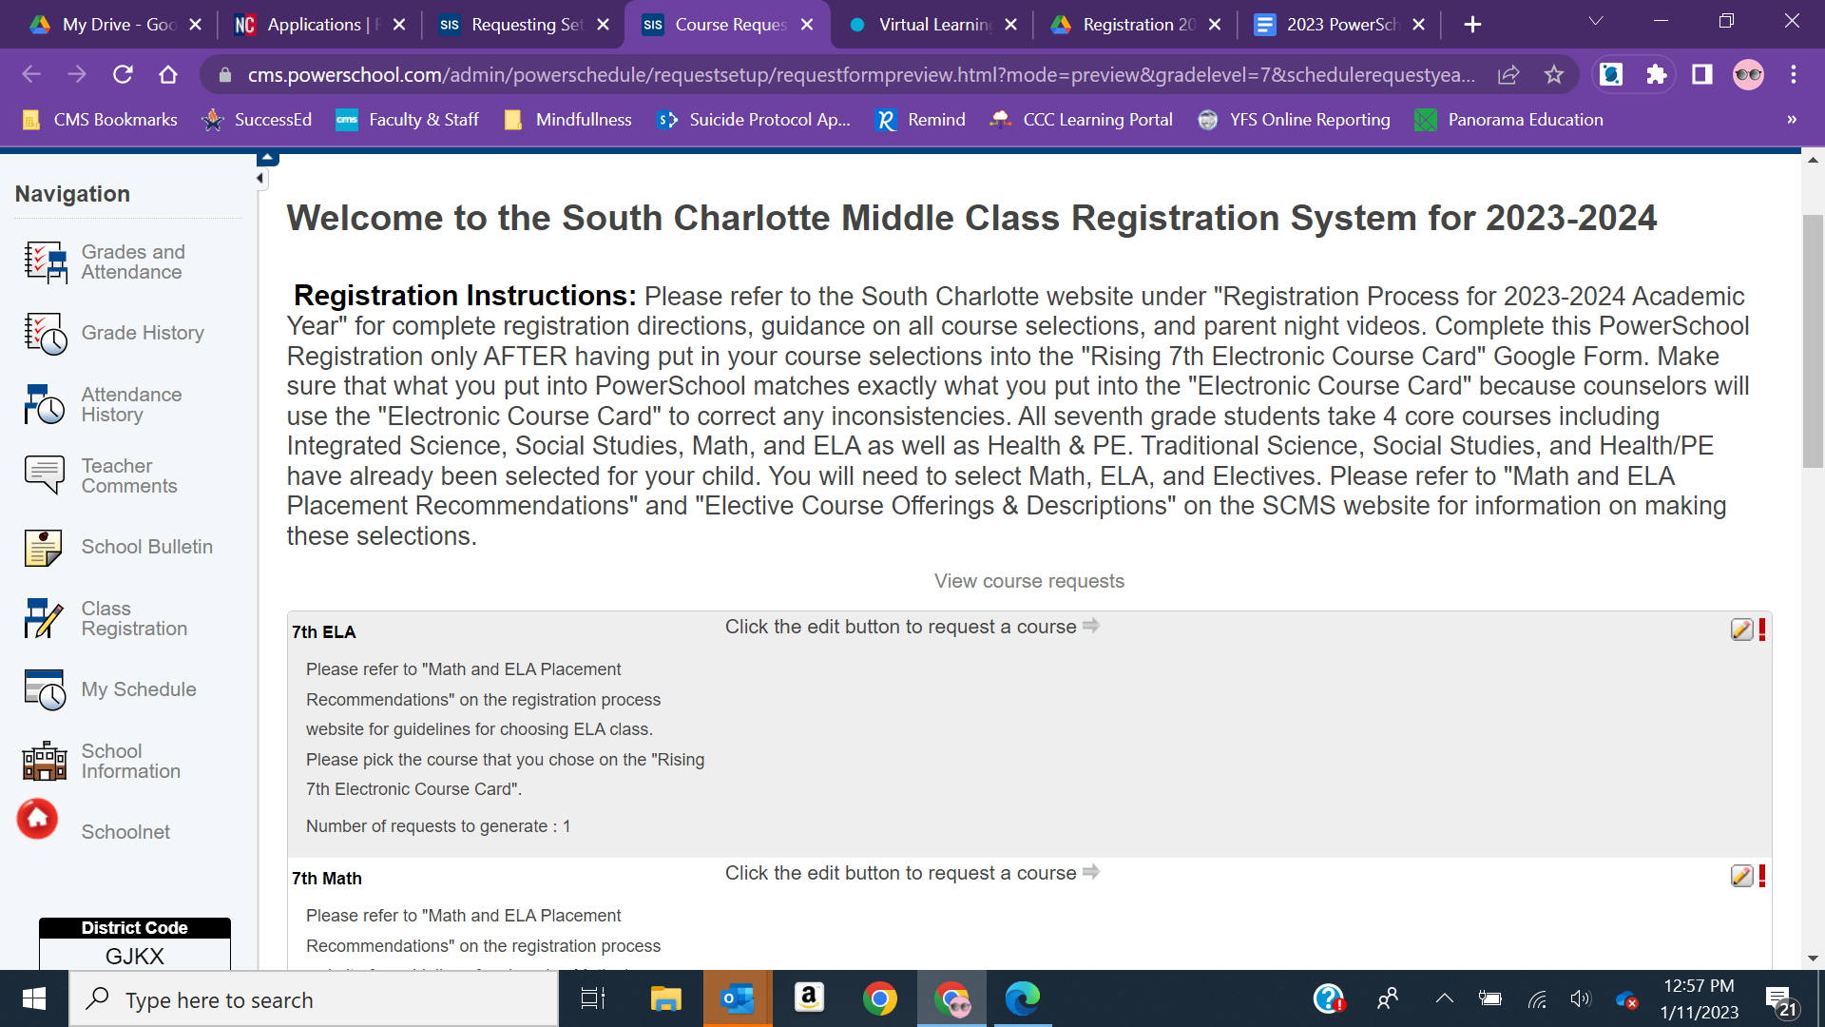

* Click the “Pencil Icon” for each section (English, Math, and electives) and select your course request for the necessary courses under each section heading.

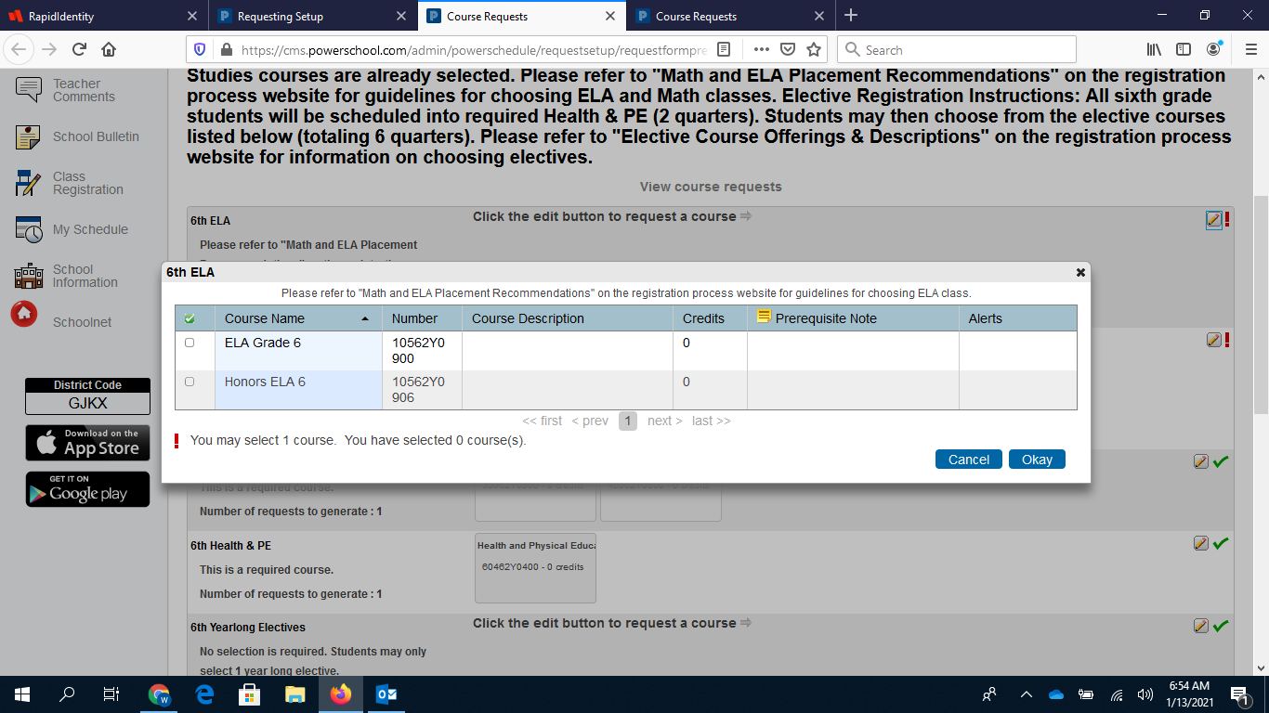

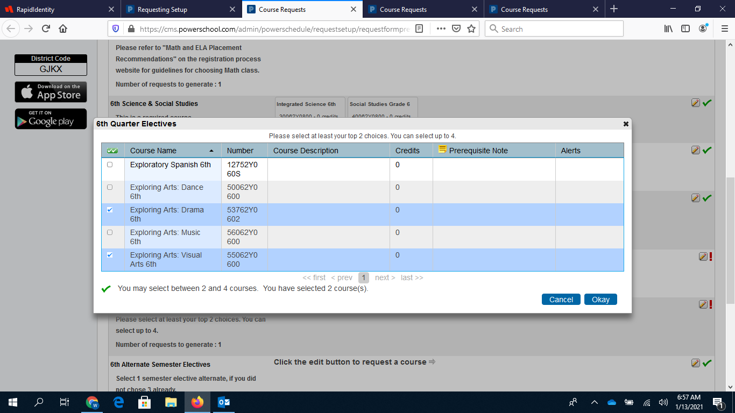

* **ELA**
* Pick the course you selected on the “Electronic Course Card”
* Click OK
* You will not be able to select Single Gender classes in PowerSchool. SCMS will utilize your selections on the “Electronic Course Card” to input this information.
* **Math**
* Pick the course you selected on the “Electronic Course Card”
* Click OK
* You will not be able to select Single Gender classes in PowerSchool. SCMS will utilize your selections on the “Electronic Course Card” to input this information.
* **Science & Social Studies**
* No selection needed
* All students will be scheduled into traditional courses
* **Health/PE**
* No selection needed
* All students will be scheduled into required Health & PE
* **Yearlong Electives**
* No selection is required, unless your child wants to take one of the courses
* Students may only take one year-long class
* Students enrolled into these courses will remain so for the entire school year
* After you have made your selection (if you chose one), click OK
* **Semester Electives**
* Select 1st Choice, 2nd Choice, and 3rd Choice from the “Electronic Course Card”
* Click OK
* **Alternate Semester Electives**
* Select 4th and 5th choice from the “Electronic Course Card”.
* Click OK
* **After you have made your choices for each section and have selected alternate courses then click the “Submit” button. After you click submit you will be able to see all of your requests.**